MUMBAI CITY PLANNING

BY-ADITYA KHATRI

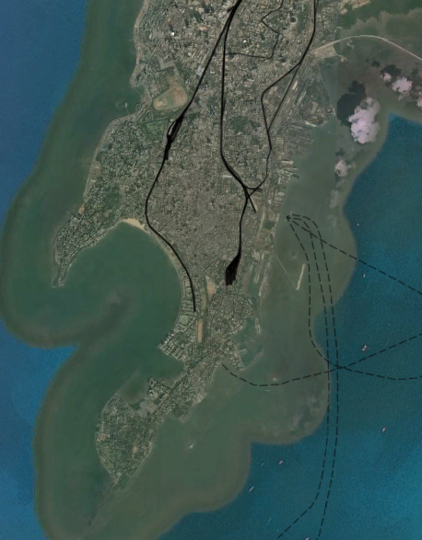

TABLE OF CONTENTS

1. INTRO MUMBAI AND ITS PROBLEMS
2. LULC OF MUMBAI
3. DEM OF MUMBAI
4. DRAINAGE MAP AND FLOW DIRECTION
5. POPULATION DESNSITY AREA WISE
6. SOIL MAP
7. PRECIPITATION MAP
8. FLOOD 3-D SIMULATION

9.CHANGE IN MUMBAI LULC(2017-2022)

10.CONCLUSION AND SUMMARY

INTRO TO MUMBAI AND ITS SEASONAL PROBLEMS

Even the smallest degree of climate change will bring about rising sea levels, varying storm patterns, and an increase in extreme weather events. With densely populated cities across the world located on coastlines and in flood zones, managing surface water is vital to the livelihoods of millions. In India, the effects of extreme flooding are already all too familiar.

This year, flooding in the state of Assam [has killed](https://www.theguardian.com/world/2020/jul/20/flooding-assam-nepal-displaces-millions-coronavirus) hundreds and displaced almost **3** **million** people. Neighbouring country Nepal has similarly been hit, with several people killed and missing. The economic impact, yet to be estimated, is expected to be in millions of rupees. Everything from [primitive flood warning systems](https://timesofindia.indiatimes.com/india/why-assams-flood-warning-system-does-little-to-prevent-loss-of-lives/articleshow/77120166.cms) to [lack of political will](https://theprint.in/opinion/india-acting-on-floods-in-bihar-and-assam-true-nationalism/465618/) is being seen as the cause.

This mirrors the story of the Mumbai floods of 26 July 2005, when the city infamously stood at a standstill. The floods resulted in the death of over **1,000** **people**and resulted in damages worth **$1.7 billion USD**, with major city services shut for almost five days. In the wake of this ‘once-in-a-hundred-year’ event, experts weighed in on potential solutions. Many believed Mumbai’s infrastructure and disaster management governance needed radical change. However, the story continues to repeat every year.

**Mumbai: the Perfect Storm**

Today, on the 15th anniversary of the floods, little is different. In fact, in 2019, the chief of the Municipal Corporation of Greater Mumbai (MCGM) [believed](https://www.indiaspend.com/as-extreme-rainfall-events-rise-mumbais-defenses-come-undone/) climate change was the culprit. This is not untrue: presently, **4.8 million** Indians are affected by flooding yearly, but this number could be **19 million** by 2030. The World Resources Institute also [suggested](https://www.weforum.org/agenda/2015/03/how-can-india-fight-back-against-floods/) that climate change is the most significant driver of urban flooding, putting Mumbai acutely at risk. An [OECD study](https://www.oecd-ilibrary.org/environment/ranking-port-cities-with-high-exposure-and-vulnerability-to-climate-extremes_011766488208) ranked Mumbai as first among coastal cities with the largest populations exposed to climate impacts by the 2070s. The McKinsey Global Institute [estimated](https://economictimes.indiatimes.com/news/politics-and-nation/climate-change-could-cost-indias-financial-capital-920-billion/articleshow/74387865.cms) **$920 billion** of damage in Mumbai due to climate-exacerbated sea level rise and flooding.

The city is the perfect storm of climate change, pre-existing planning problems and inefficient infrastructure.

***Seven Islands that are One***

Originally made up of seven discrete islands, the shape of Mumbai today has been defined by land reclamation over hundreds of years. The shape of the city has been changing continuously, until as late as the 1990s.

When it rains, water running off the surface is collected by rivers or other conveyance channels, and seeps into the ground. Ultimately, the water is taken up by plants, recharges the natural groundwater capacity, or flows back to the sea.

In the case of Mumbai, much of the rainwater drains into the lowest lying areas — the parts historically reclaimed from the sea. With every inch of the city inhabited and built up, concrete is ubiquitous, making it hard for any of the rain to seep into the ground. Finally, the only water body the rain can drain into is the Mithi River. Years of risky development has rendered the river — the lifeline of Mumbai — less than suitable for the task.

***Reduced Natural Drainage Capacity***

The Mithi is the confluence of the Powai and Vihar lakes at the north of the city. Its mouth was once hundreds of meters wide, but over the decades, this has been reduced to barely **40** **meters**. There has been encroachment over its actual course, too. Most prominently, the Bandra-Kurla Complex and Mumbai’s Chhatrapati Shivaji International Airport reclaimed land on the Mithi.

Lack of waste management regulation has simultaneously led to illegal pollution of the river, all in all reducing its capability of resisting flood surges.

Due to a heavy focus on infrastructure development and urban growth, Mumbai’s natural drainage paths have been concretised and built over. To contrast, Rotterdam is [one of the safest delta cities](https://www.weforum.org/agenda/2019/01/the-world-s-coastal-cities-are-going-under-here-is-how-some-are-fighting-back/) in the world precisely because it has learned to live with, rather than above, water.

The city’s ecosystem-based development solutions attempt to mimic natural drainage pathways. Working together with regularly upgraded sewerage infrastructure, Rotterdam’s unique ecology has been a gift to its residents in times of heavy rainfall.

Such sustainable drainage strategies have immense potential to enhance urban resilience, but in Mumbai’s case, they have been routinely ignored. Millions are thrown every year at the Brihanmumbai Stormwater Disposal System (BRIMSTOWAD) project to overhaul the sewerage system by installing new pumping stations and repairing old pipelines. However, investment in [nature-based solutions](https://www.degreesofchange.in/articles/week-in-a-warming-world) is neglected.

***Climate as a Risk Multiplier***

Climate change will not present a new question to Mumbai’s flooding conundrum — it will simply [multiply risks](https://www.degreesofchange.in/articles/pandemic-climate-change-lessons) the city already faces. Natural climate solutions such as mangroves and wetlands can alleviate these risks by acting as sponges, but continue to be destroyed due to lack of appropriate flood zoning.

Mumbai has a total of **5,300 acres** [of salt-pans](https://mmrda.maharashtra.gov.in/development-of-salt-pan-lands?redirect=https%3A%2F%2Fmmrda.maharashtra.gov.in%2Fwho-we-are%3Fp_p_id%3D3%26p_p_lifecycle%3D0%26p_p_state%3Dmaximized%26p_p_mode%3Dview%26_3_advancedSearch%3Dfalse%26_3_groupId%3D0%26_3_keywords%3D%26_3_delta%3D75%26_3_resetCur%3Dfalse%26_3_cur%3D17%26_3_struts_action%3D%252Fsearch%252Fsearch%26_3_format%3D%26_3_andOperator%3Dtrue), entirely marked as wetlands. Along with mangroves, salt pans hold seawater outside the city and prevent urban flooding. However, the [2017 Wetlands rules](http://www.indiaenvironmentportal.org.in/files/file/Wetlands%20(Conservation%20and%20Management)%20Rules,%202017.pdf) decided that salt-pan lands were no longer marked as wetlands, opening them up for development. Changes to Mumbai’s Development Plan (DP) 2034 further [indicate](https://india.mongabay.com/2019/10/salt-pans-save-mumbai-from-floods-so-why-are-they-under-threat/) that the government is working towards building an ambitious low-cost housing project on these salt pans.

In 2005, the Concerned Citizens’ Commission on the Mumbai Floods [clearly highlighted](http://cat.org.in/wp-content/uploads/2017/03/Mumbai-Marooned-An-Enquiry-into-Mumbais-Floods-2005.pdf#page273) these and other critical concerns. They suggested a combination of urgent mitigative and adaptive measures to city leadership. Nevertheless, the [prevailing belief](https://books.google.co.in/books?id=wh8lDwAAQBAJ&lpg=PA270&dq=mumbai%20flooding%20solutions&pg=PA270#v=onepage&q=mumbai%20flooding%20solutions&f=false) was that improved sewerage infrastructure would be a magic bullet to vanquish the flooding monster, and millions were poured into the proposed Brihanmumbai Stormwater Disposal System (BRIMSTOWAD).

Such a strategy ironically prioritises purely infrastructure-centric solutions for problems that originally arose due to the rampant development of infrastructure. Local political misdirection is certainly responsible. However, the proclivity to believe that environmental issues can be addressed through technology alone is rather universal, experienced in every sector and every country. An interdisciplinary approach is perhaps the only way to understand that to truly move forward, we must acknowledge the different roads that have brought us to this precipice.

**The Way Forward**

***Building Climate Resilience***

The concerns highlighted above only scratch the surface of the larger Mumbai flooding puzzle — one that can never be solved through a narrow technical viewpoint. Considering the city’s vulnerability to climate change compounded by its unique geography, infrastructural challenges and governance landscape, a robust action plan must include perspectives from diverse fields.

***Investing in Natural and Built Infrastructure***

Natural climate solutions such as mangroves, salt pans, green roofs and urban wetlands play an important role in helping Mumbai reclaim its ecological alignment. Integrating sustainable urban drainage mechanisms such as permeable paving and biological retention in new construction needs to be a priority. China’s ‘[Sponge Cities](https://www.theguardian.com/cities/2019/jan/23/inside-chinas-leading-sponge-city-wuhans-war-with-water)’ initiative is an exemplar of the same.

The BRIMSTOWAD project planned to overhaul Mumbai’s drainage by installing new pumping stations and repairing pipelines. Fifteen years on, not even 50 percent of the work planned has been completed. Fast-tracking of this project will need to be combined with systematically clearing the Mithi river (a process known as *desilting*).

***Improving Governance and Regulation***

There is a clear need to [improve environmental governance](https://www.degreesofchange.in/articles/reshaping-indian-governance-climate-change) in India, an action that can catalyse enhanced climate [resilience](https://www.resilience.org/the-science-of-resilience/) as well as greater infrastructure investment. Regulatory framework design and implementation simultaneously needs to be improved. Adjusting zoning laws will cut construction in at-risk coastal areas and flood plains. This will reduce the number of people impacted while concurrently preventing rainwater from flooding into urbanised areas. Better waste management legislation is likewise essential, and presents Mumbai with far-reaching co-benefits.

***Strengthening Disaster Preparedness***

Flooding is endemic to Mumbai due to its topography and ecology, meaning that we may not be able to cure the problem entirely. We can, however, ensure that if we continue to be affected, the worst of the disaster can be averted.

Mumbai’s current disaster management systems urgently need to be upgraded. This should be done by rigorously integrating advanced technology. Robust early warning systems that alert citizens of day-to-day weather projections and predictions can help save lives and prevent catastrophe. Food and drinking water, first aid and resilient electricity supply must be provisioned. Scientific collaborations and community leadership can play a key role here.

***Building Partnerships and Learning Exchanges***

With every single one of Mumbai’s residents and businesses facing a growing threat, the opportunity to leverage multi-stakeholder partnerships will prove critical.

Just the July 2005 floods [incurred losses](https://link.springer.com/article/10.1007/s10584-010-9979-2) of **$140 million** to trade, and **$227.5 million** to industrial infrastructure. The risk due to climate change is being increasingly priced into business decisions and Mumbai’s vulnerability is sure to be a recurring conversation in the private sector. This conversation must collectively advocate for innovative models to finance mitigation, resilience and disaster preparedness.

It is important to note that Mumbai is not the only city to face the burden of urban flooding. Sharing learnings between vulnerable cities can ensure the implementation of best practices from around the world. Taking the knowledge from Mumbai’s fight against flooding into other sectors also presents a significant opportunity. By understanding successes and failings gathered over the years, we will be able to co-create a proactive, interdisciplinary approach for tackling climate impacts worldwide.

LULC OF MUMBAI

SUPERVISED

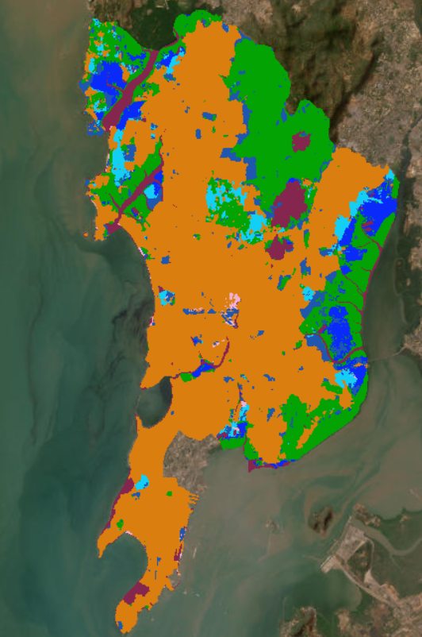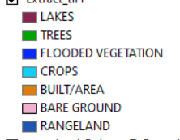

UNSUPERVISED

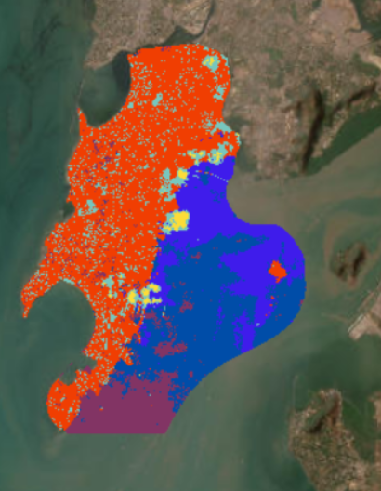

DEM OF MUMBAI

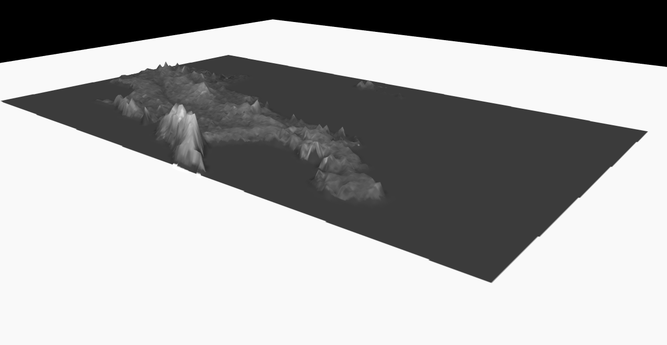

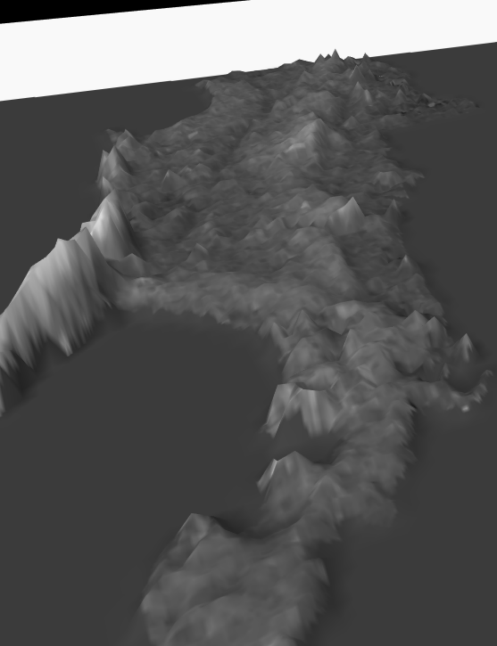

SOUTHERN BOMBAY IS PRONE LESS PRONE TO FLOODS AS WE CAN SEE FROM DEM THE ELEVATION IS ALSO HIGHER AS COMPARED TO CENRAL BOMBAY

DRAINAGE MAP AND FLOW DIRECTION

STRAHLER ORDER

ITS AN ORDER VARIES FROM 1-9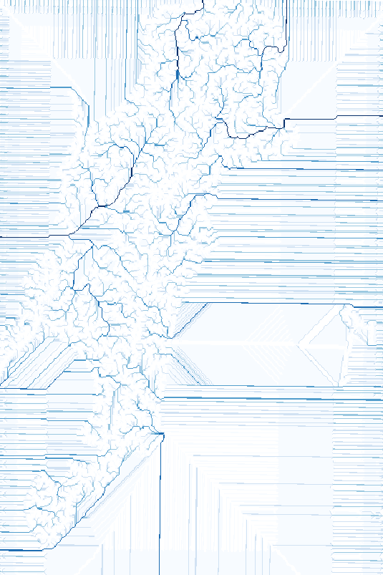

THE HIGHER THE NUMBER THE HIGHER IS THE FLOW ACCUMULATION AND STREAM

SMALL STREAMS HAVE LOWER STRHALER NUMBER AND VICEVERSA

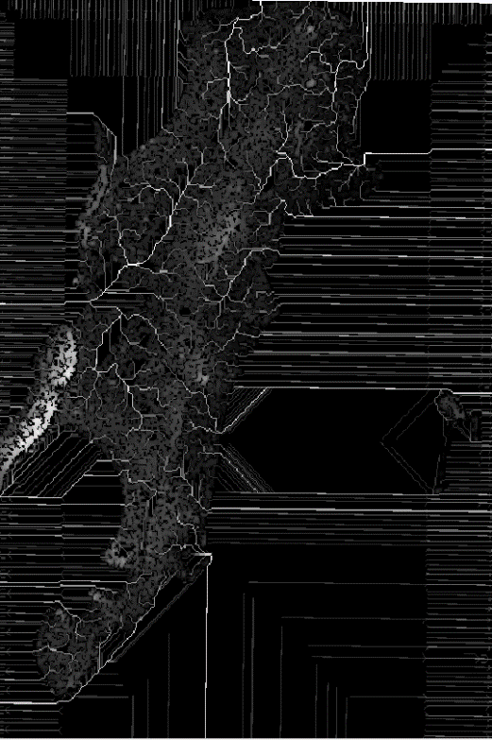 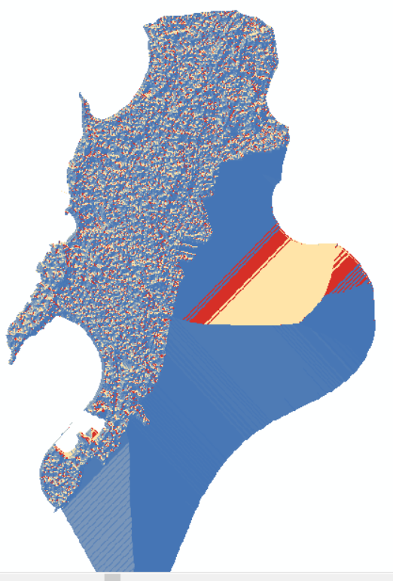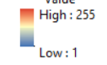

FLOW DIRECTIONS

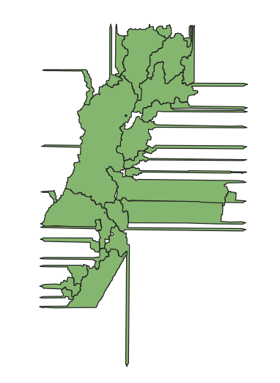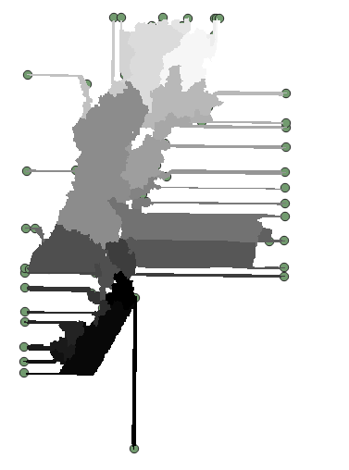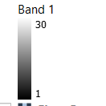

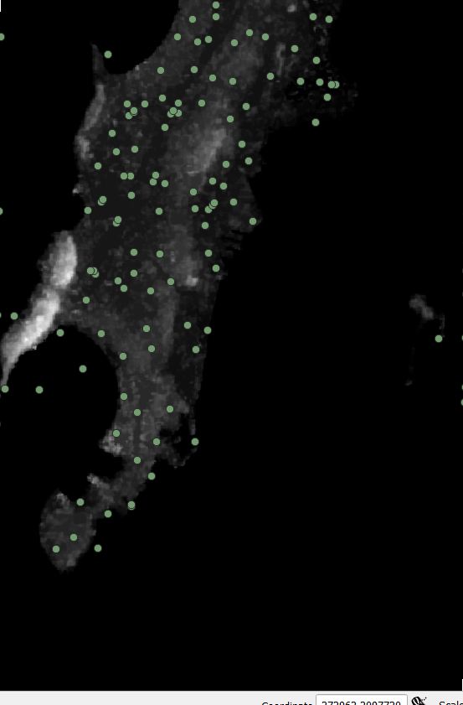

JUNCTION OF SEWAGE IN MUMBAI

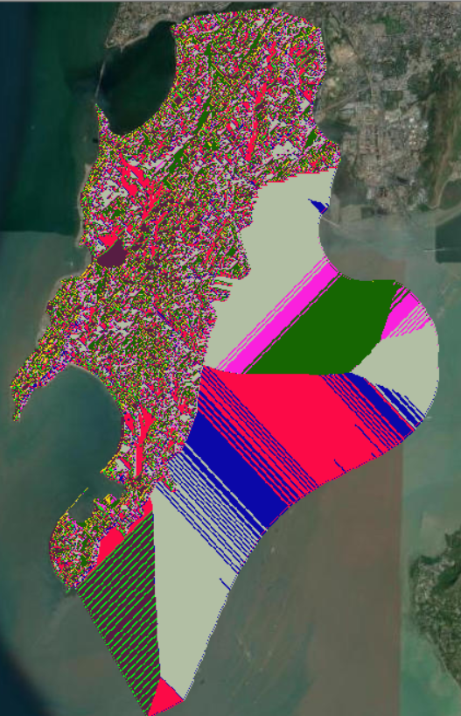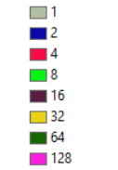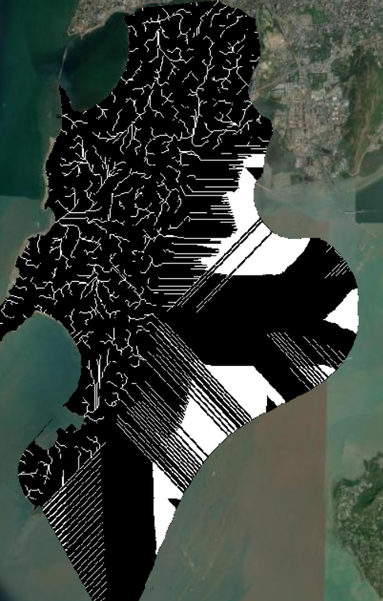



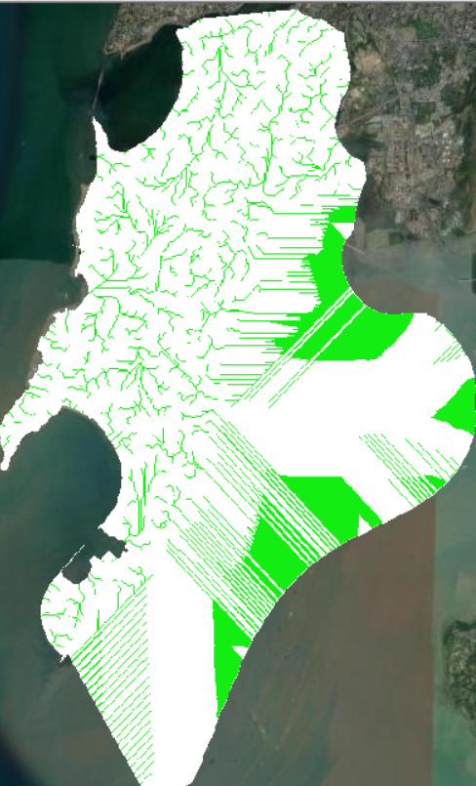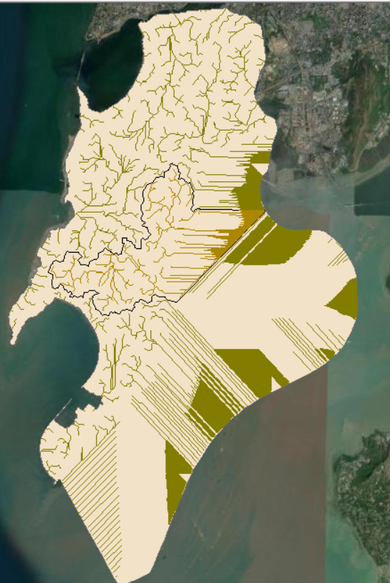

Pics show central Bombay streams central Bombay has more floods

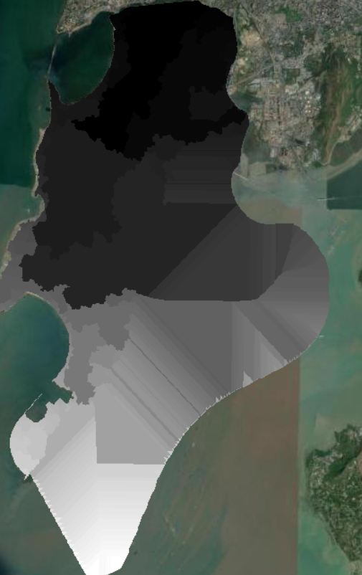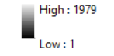

Basin flow

POPULATION DENSITY MUMBAI

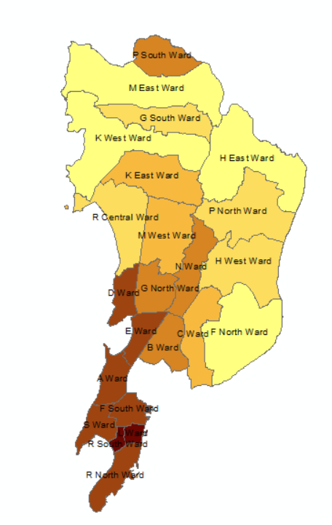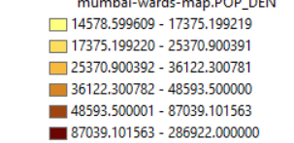

The map shows division of population in Mumbai as we can see south has much more population density as compared to central Bombay economy wise also south Bombay is much more prosperous and developed the areas in south Bombay are planned nicely as compared to central Bombay .

SOIL MAP BOMBAY

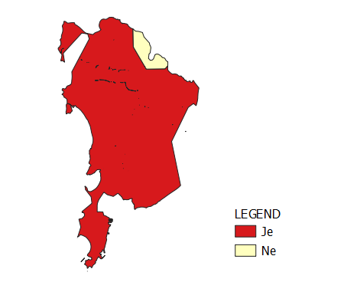je=Eutric Fluvisols

Ne=Eutric Nitosols

Eutric Fluvisols

A **fluvisol** in the [World Reference Base for Soil Resources](https://en.wikipedia.org/wiki/World_Reference_Base_for_Soil_Resources) (WRB) is a genetically young soil in [alluvial](https://en.wikipedia.org/wiki/Alluvial) [deposits](https://en.wikipedia.org/wiki/Sediment) . Apart from river sediments, they also occur in [lacustrine](https://en.wikipedia.org/wiki/Lake) and [marine](https://en.wikipedia.org/wiki/Marine_(ocean)) deposits

Eutric Nitosols

**One of the best and most fertile soils of tropics**. They can suffer acidity and P-fixation, and when organic carbon decreases, they become very erodible. But erosion has only slight effect on crops. Nitosols have moderate resilience and moderate to low sensitivity.

Bombay soil is very much fertile and have high water absorbing capacity

So problems doesn’t lie here

PRECIPITATION MAP

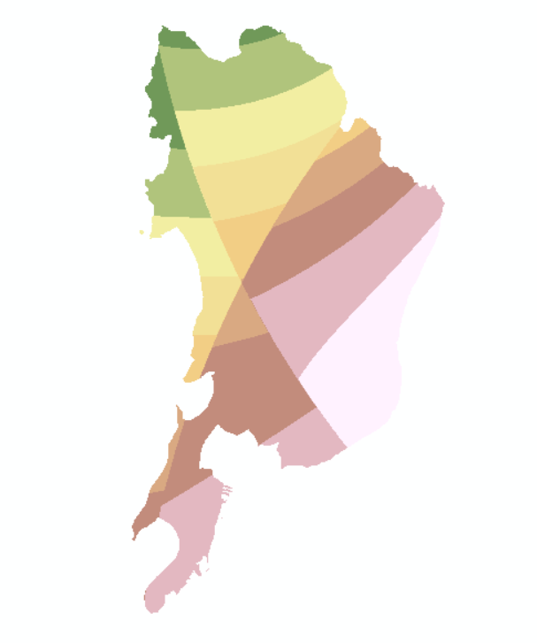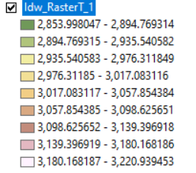

THE MAP SHOWS AVG RAINFALL 2011-2020

FLOOD RISK ASSESMENT

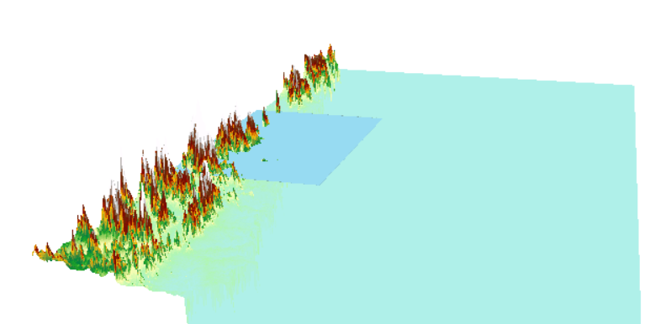

THIS ANIMATION SHOWS THE HOW WILL FLOOD AFFECT MUMBAI WHEN IT COMES

MUMBAI LULC CHANGE (2017-2022)

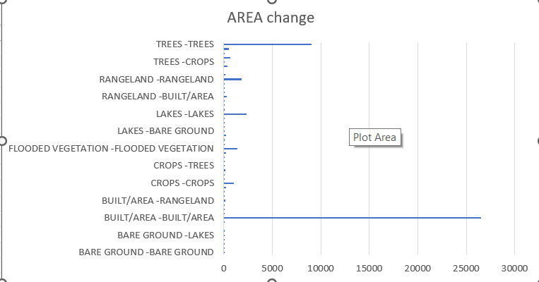

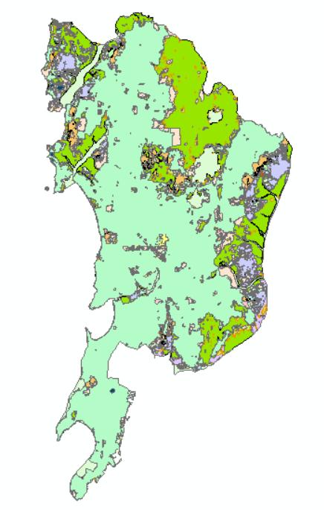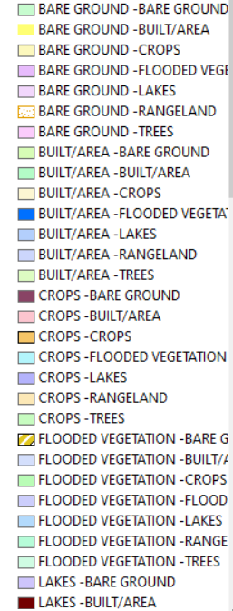

CONCLUSION AND SUMMARY

1)we have seen from above maps that despite south Bombay being close to sea and have more rains have less floods reason being improved drainage system south Bombay has nice flood drainage system

2)seen in above composite image Mumbai has more concrete cover the cover needs to be reduced and sponge cities system needed to be implemented to drain out more water

3)sustainable development should be promoted Mumbai is a rapidly growing city in exchange of development we are reducing forest cover as seen from lulc change in Mumbai over years

4)plans should be changed according to city population as seen by population density map these maps should be kept up to date to change plans according to it

5)most important public should have awareness about risk of flooding and should be encouraged to make flood resistant houses

6)early warning systems should be kept updated and cities which have more precipitation as seen from precipitation map have more early and best early warning systems

7)lastly rainwater harvesting can be implemented in cities which sees rain more often and dams can be constructed in these cities more in number to conserve water as well to prevent flooding

8)Mumbai soils are of alluvial type which has natural water holding capacity sponge cities can be avoided if budget fails provided Mumbai has more forest cover and less concrete and alluvial soils on sideways of roads